Sns with terraform:

Using state files and passing variables  
  
creating sns topics and subscription  
  
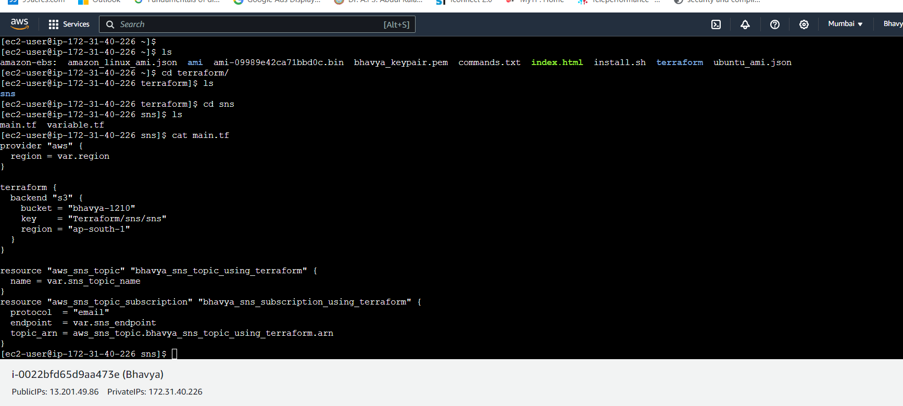

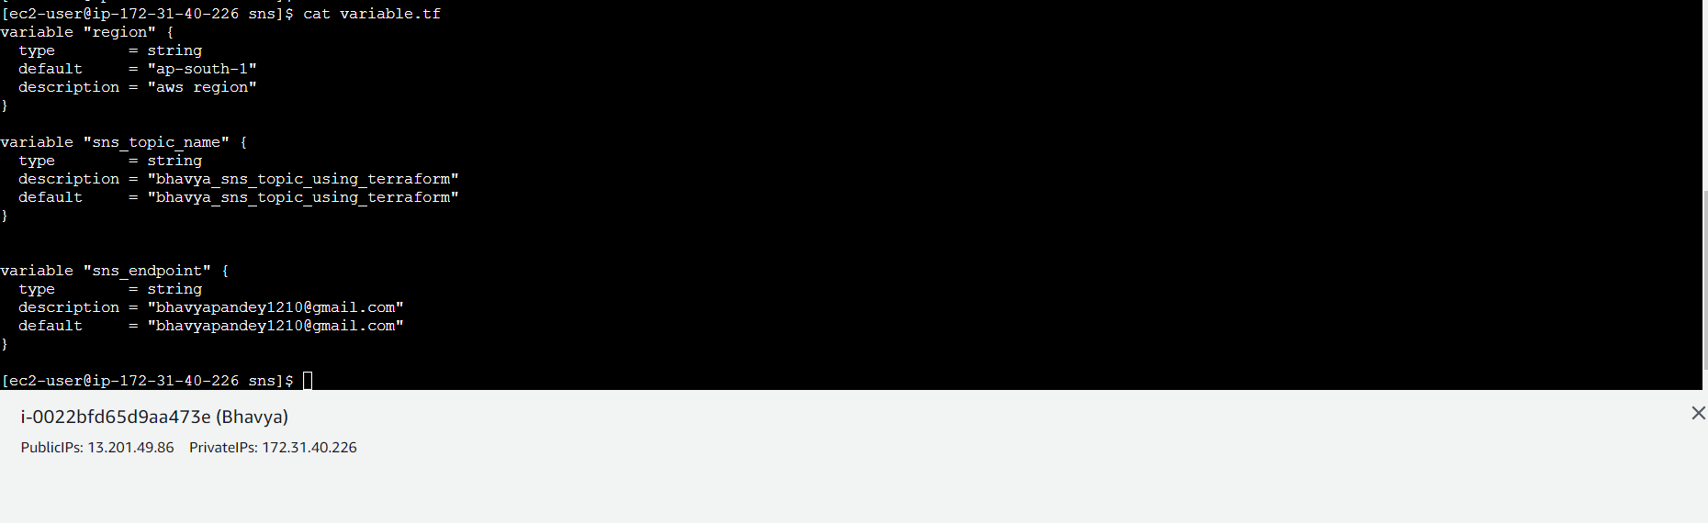

Terraform init

Terraform fmt

Terraform plan

Terraform apply